22.13: 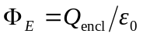
The flux through the sphere depends only on the charge within the sphere.

